- To write a program to implement Cohen Sutherland line clipping algorithm and to perform window to viewport transformation.

Line Clipping:

- Start
- Read the rectangular frame coordinates values rx₁ , ry₁, rx₂, ry₂
- Read the line coordinate(x,y)
- Find the slope of the line and the corresponding intersection values with the rectangular frames
- Clip the portion of the line which lies outside the rectangular frame and retain the portion of the line that lies inside the rectangular frame
- Stop

Window to Viewport Transformation:

- Start
- Assign the viewport coordinates in the variables v₁, v₂, v₃, v₄
- To perform transformation use the corresponding line coordinates
- Determine the scaling factors using the formula s_{x} = v₃- v₁ / rx₂ – rx₁ & s_{y} = v₄- v₂ / ry₂ – ry₁
- Map the line to the viewport using the line coordinate and the scaling factors
- Display the viewport
- Stop

Input: Enter the co-ordinates of rectangle: 200 200 400 400
Co-ordinates: 250 350 450 350
Before Clipping…..
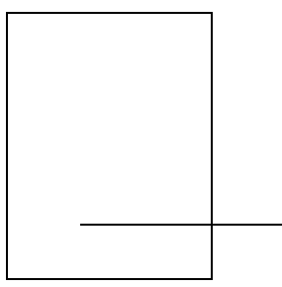
Press any key…….
int rx1 = 200,ry1=200,rx2=400,ry2=400;
int h=rx2-rx1;
int w =ry2-ry1;
int lx1=250,ly1=350,lx2=400,ly2=350;
float fx1,fx2,fy1,fy2;
int m;
float n;
void setup() {
size(500, 500);

}

void draw() {
background(255);
m=(ly2-ly1)/(lx2-lx1);
if(m!=0){
n=1/m;
}
if(ly1<ry2 && ly1>ry1){
fy1=ly1;
}
else{
fy1=ly1+m*(rx1-lx1);
}
if(lx1>rx1&&lx1<rx2){
fx1=lx1;
}
else if(m==0){
fx1=rx1;
}
else{
fx1=n*(fy1-ly1+(m*lx1));
}
if(ly2<ry2 && ly2>ry1){
fy2=ly2;
}
else{
fy2=(ly2+m*(rx2-lx2));
}
if(lx2>rx1&&lx2<rx2){
fx2=lx2;
}
else if(m==0){
fx2=rx2;
}
else{
fx2=n*(fy2-ly2+(m*lx2));
}
rect(rx1,ry1,h,w);

line(fx1,fy1,fx2,fy2);
}
After Clipping……
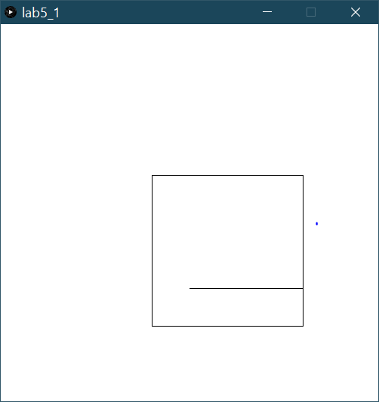

Press any key……..
int rx1 = 200,ry1=200,rx2=400,ry2=400,lx1=250,ly1=350,lx2=400,ly2=350;
int vx1=150,vy1=150,vx2=300,vy2=400;
int h=vx2-vx1;
int w =vy2-vy1;
float fx1,fx2,fy1,fy2,sx,sy;
int m;
float n;
void setup() {
size(500, 500);
}
void draw() {
background(255);
sx = (float)(vx2 - vx1) / (rx2 - rx1);
sy = (float)(vy2 - vy1) / (ry2 - ry1);
m=(ly2-ly1)/(lx2-lx1);
if(m!=0){
n=1/m;
}
if(ly1<ry2 && ly1>ry1){
fy1=ly1;
}
else{
fy1=ly1+m*(rx1-lx1);
}
if(lx1>rx1&&lx1<rx2){
fx1=lx1;
}
else{
fx1=n*(fy1-ly1+(m*lx1));
}
if(ly2<ry2 && ly2>ry1){
fy2=ly2;
}
else{
fy2=(ly2+m*(rx2-lx2));
}
if(lx2>rx1&&lx2<rx2){
fx2=lx2;
}
else if(m==0){
fx2=rx2;
}
else{
fx2=n*(fy2-ly2+(m*lx2));
}

rect(vx1,vy1,h,w);
fx1 = (int) (vx1 + (float)((fx1 - rx1) * sx));
fy1 = (int) (vy1 + (float)((fy1 - ry1) * sy));
fx2 = (int) (vx1 + (float)((fx2 - rx1) * sx));
fy2 = (int) (vy1 + (float)((fy2 - ry1) * sy));
line(fx1,fy1,fx2,fy2);
}

Window to view port mapping
